Table of Contents

Introduction 2

Assumption 2

Sample outputs 3

Login Page 3

User Registration 4

Purchase Ticket 5

Save Ticket 6

View Purchased Tickets 7

Sample Code 8

Classes 8

Objects 9

Constructor 9

Inheritance 10

Additional Features 11

Save ticket 11

Text File as Database 12

References 13

# Introduction

The delivered system has been developed using java programming language and using text file as database to store and retrieve the required data.

Java is a general-purpose computer programming language that is concurrent, class-based, object-oriented, and specifically designed to have as few implementation dependencies as possible. It is intended to let application developers "write once, run anywhere" (WORA), meaning that compiled Java code can run on all platforms that support Java without the need for recompilation.

## Assumption

The application is developed to organized APU’s bus ticketing system. All the buses has 30 seats and users are able to choose their preferred seats from the available choices for the specific destination and data and time.

The buses are providing transportation between APU and four other places which are Melaka, Ipoh, Seremban and Kuantan. The user has to Sign in to the system using their own credential which can be created using sign up function. After signing to the system they need to choose the origin, travelling date and time and destination, the system will show the available seats and user can choose and purchase the ticket. After purchasing the ticket user can save it as a text file in the local machine and also check the ticket’s purchase history which is showing all the purchased ticket by the specific user.

After purchase the chosen seat will be blocked and no other user can buy the ticket for that seat in the chosen journey.

# Sample outputs

## Login Page

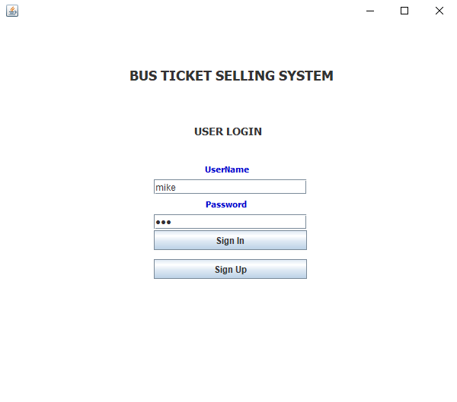

The initial and first page of application is login page, in this page users can log in into their account by entering their user name and password, if the user enters correct user name and password the application will open the purchase page otherwise it shows the error.

The user can sign up for new account by pressing the sing up button.

## User Registration

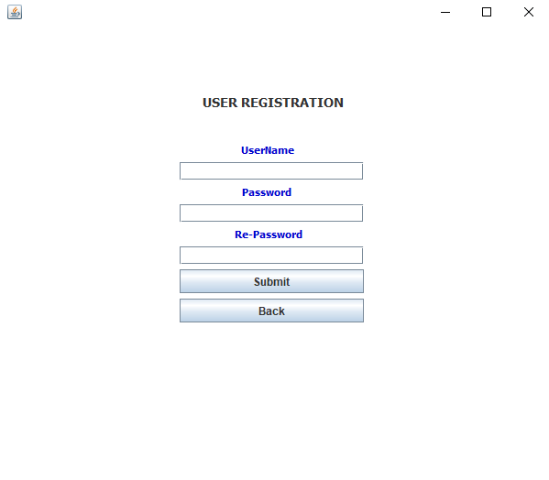

in this page users can sign up for new account by choosing a user name and password, the system will check for the user name and if the same username exists it will show the error, it also validate the password and in case the password and re-password field do not match it will show the user, after all validation the new account will be created and user can use it to sing in into the system.

## Purchase Ticket

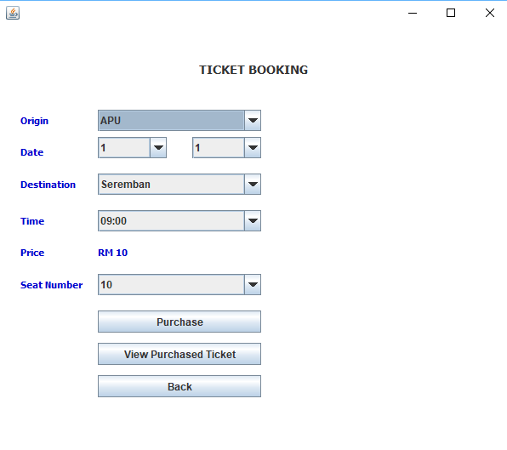

In this page users can purchase the ticket, they need to choose the origin, travel data and destination, then the available time will be shown after choosing the travel time the available seat number will be shown on the list and user can choose their own preferred seat and press purchase button, they also can check their purchase ticket history by clicking on View Purchased Ticket button.

## Save Ticket

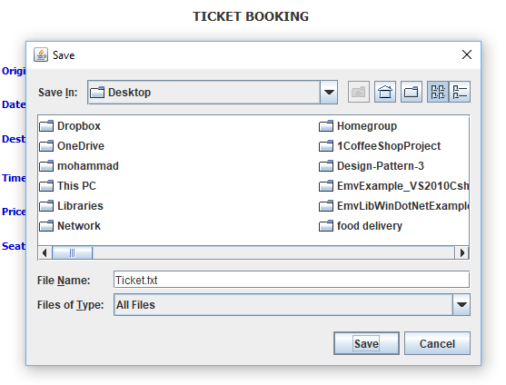

After pressing the purchase ticket a page will pop out which make users to save their ticket on their local machine.

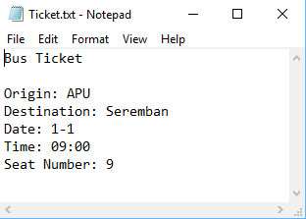

The user can check and print out their ticket by opening the saved text file.

## View Purchased Tickets

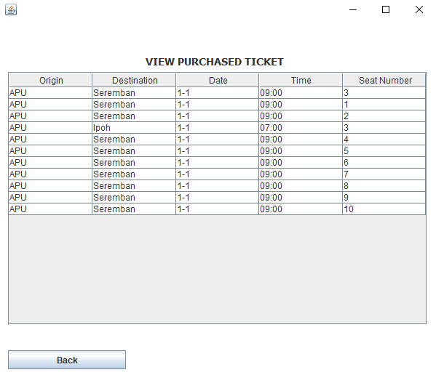

In this page users can check all the purchased tickets and their details such as origin, destination, date, time and seat number.

# Sample Code

Java is an object oriented programming language in this application the below OO concepts have been used.

## Classes

This application contains different classes to accomplish different processes, in the below image you can see the list of classes in the application.

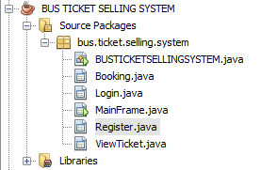

As it shown in the screen shot this application contains six different classes which all of them include their own functions and variables. In the below screen shot you can see the MainFrame java class which has been declare as public and has its own functions.

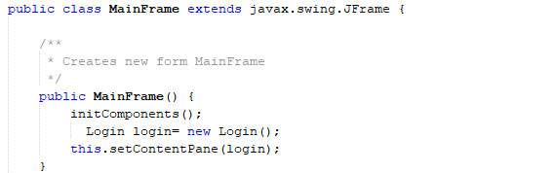

## Objects

To access each class function and variable and use its functionality, you need to create an object of that class. It is really important to know with an object of a class you can only access and use public functions and variable and the rest of the function and variable will only be accessible from inside of the class. In the below screen shot you can see declaring the object of Register and Booking classes in the Login class.

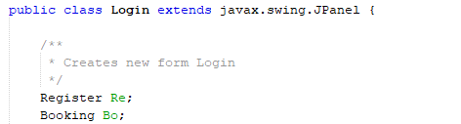

## Constructor

Constructor is a function which will be called once an object of a class is created, constructors are the only functions which does not have any return value type and they should have the same exact name of their class. In the below screen shot you can see Register class and its own constructor.

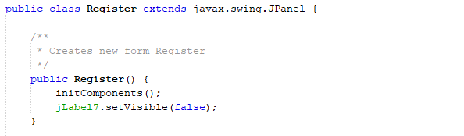

## Inheritance

Inheritance in java is used to add additional functionalities to the existing class. Inheritance is used to extend the present class by adding some more properties to it. Inheritance is used to reuse the present tried and tested code so that you may not have to write them and compile them again.

In the below screen shot you can see that Login class is inheriting the “javax.swing.JPanel” class which is providing the GUI functionality for it. Now the login class can use all the functions in jPanel class such as jTextField and all other GUI components.

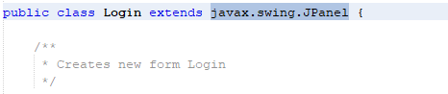

# Additional Features

## Save ticket

The application has the functionality to save the purchased ticket as a text file which include all the ticket details, the system will create a dynamic file chooser and create a text file instantly and save in the chosen location by the user. The below screen shot is showing the process of creating and saving ticket.

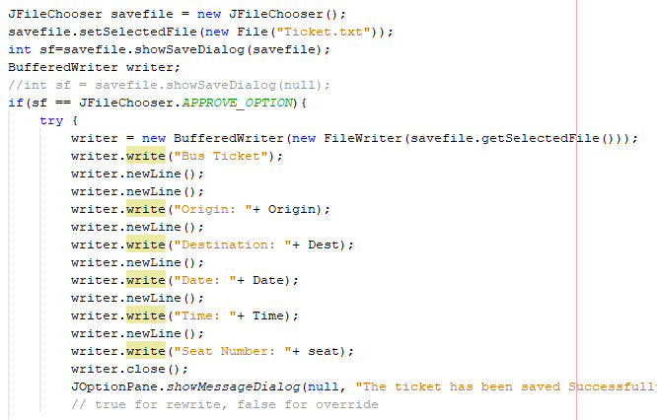

## Text File as Database

The system is using text file as database to store the user and purchased information, there are two text file one is to store the user credential information such as user name and password and the other one is using to store ticket purchase data. Each line of the text file will include the information of one object and works like a database row, data will be separated with space character.

In the below screen shots you can see the code to insert and read data in user text file.

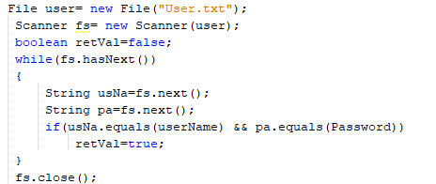

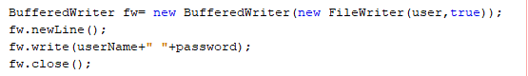

# References

## 

1880-1954, H. (2013). *Java head*. [Place of publication not identified]: Hardpress Ltd.

Java Concept Of The Day. (2017). *Inheritance In Java - Java Concept Of The Day*. [online] Available at: http://javaconceptoftheday.com/inheritance-in-java/ [Accessed 9 Jul. 2017].

Object-Oriented Programming Languages: Tools for Effective Communication on Application. (2016). *International Journal of Science and Research (IJSR)*, 5(8), pp.406-411.

Sabharwal, C. (1998). Java, Java, Java. *IEEE Potentials*, 17(3), pp.33-37.